# **ChatBuddy Pro Manual Testing**

1. Dashboard
2. Clicking this chatbuddy pro icon :

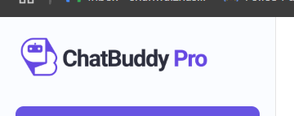

Takes me to landing page on a new tab and for some reason there is written sign in even when I logged in

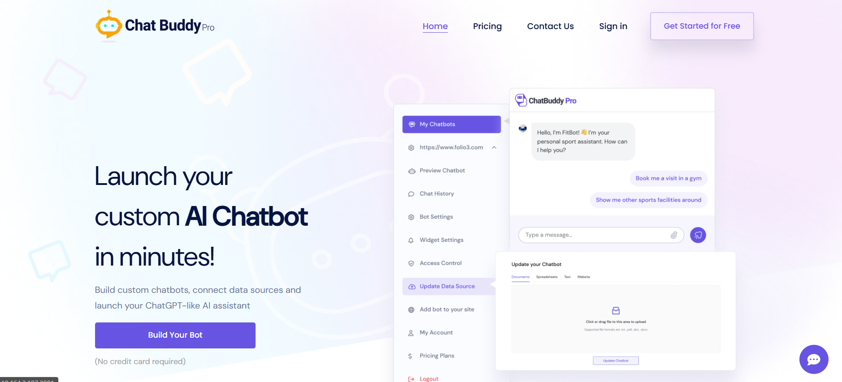.

Then when I click Sign in it doesn’t take my credentials to sign in but auto logs me in and a blank screen is shown: (Functional and UI)



1. My Account
2. Password Field:

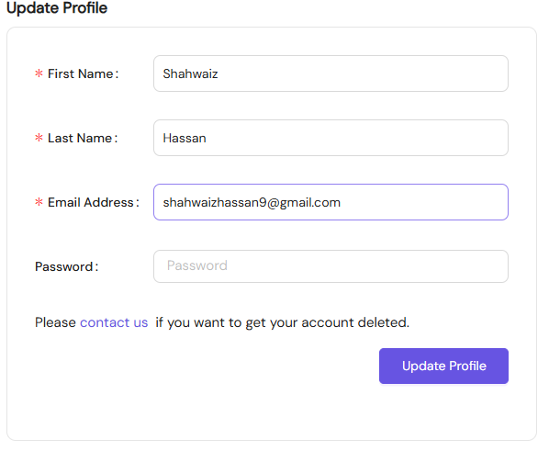

This password field here is very unclear as a user can’t know that is it mandatory to fill this field or not. It should be labelled optional field for more clearance and understanding (UI)

1. Pricing
2. When cancel subscription, there isn’t any option to go back to dashboard as the website logs user out when user clicks on go back button provided. (Functional)

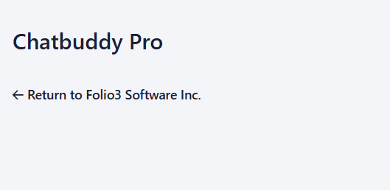

1. When a subscription is cancelled a user can only renew that cancelled subscription but cannot subscribe to any other plan. (Functional)
2. Chatbots

Testing chatbots with all kinds of input documents and website URL.

* Creating chatbots with medium sized files or website URL takes a lot of time. (Functional)
* If I am creating chatbot and the loader is spinning and I click back the loader also comes on the other page:(UI)

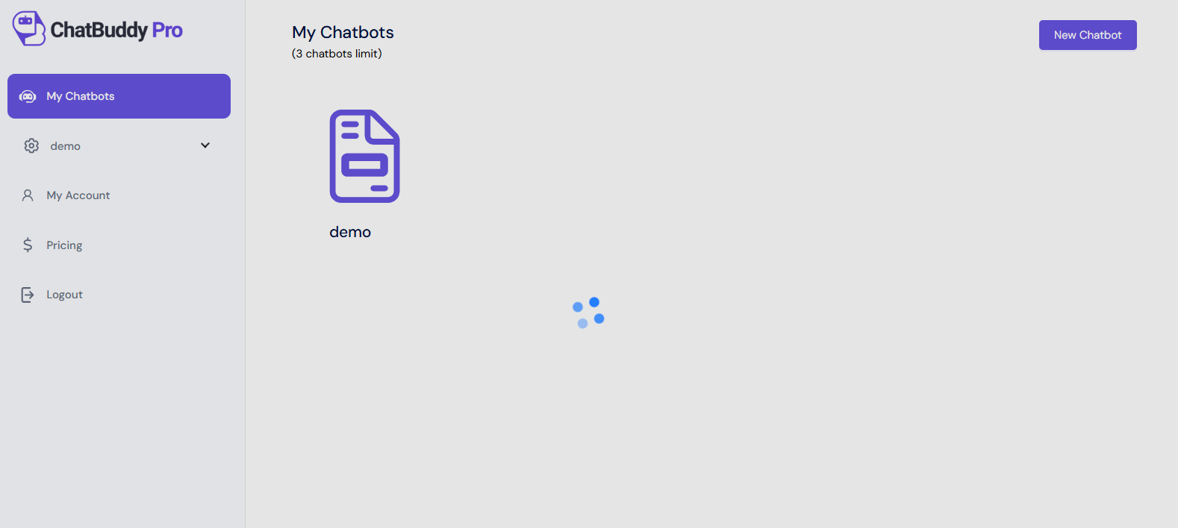

* The chatbot cannot upload .doc file and make a chatbot of it. (Functional)
* Chatbot gives error when we give it xls and csv file. It only works for xlsx file: (Functional)  
  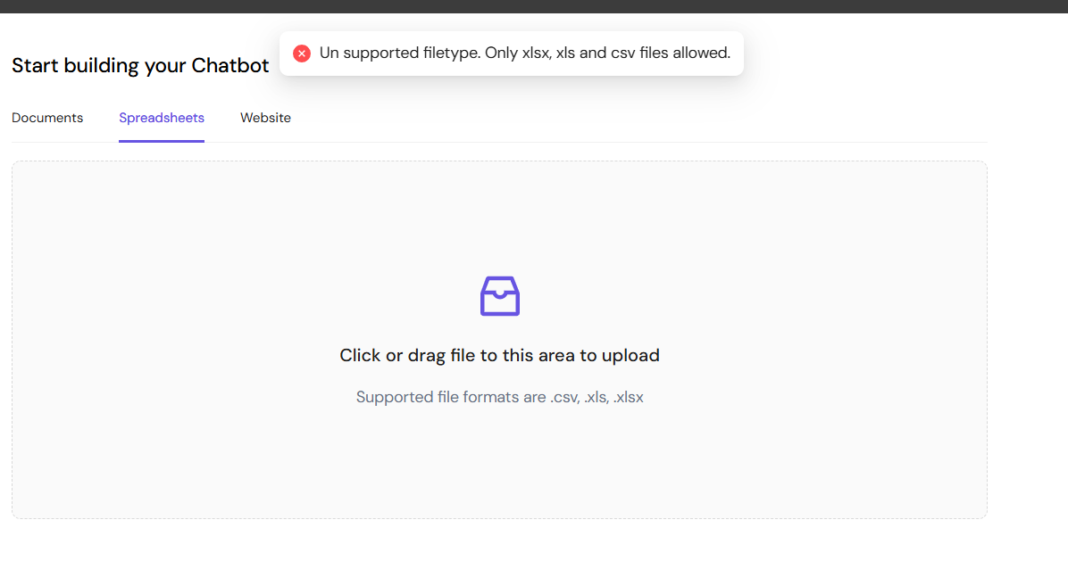
* Chatbot confuses permissions, headers and footers and focuses on them not ignoring them and only focusing on the main content when created by given a website URL. (Functional)

1. Preview Chatbot

* No welcoming or starting message in the Preview chatbot section. (Functional)
* When the bot replies, it puts double steric before and after keywords. It should not do that but rather bold or highlight those keywords (Functional and somewhat UI)

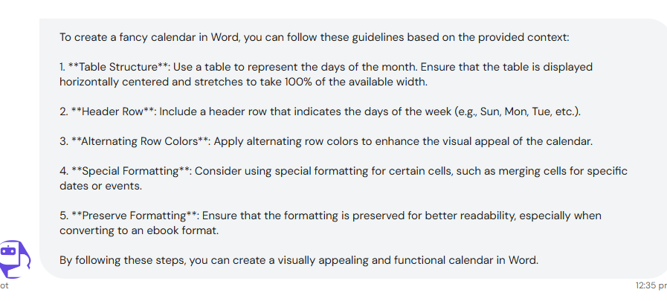

1. Chat History

* Latest chat history shall be shown on left side and it should not be empty: (Functional)

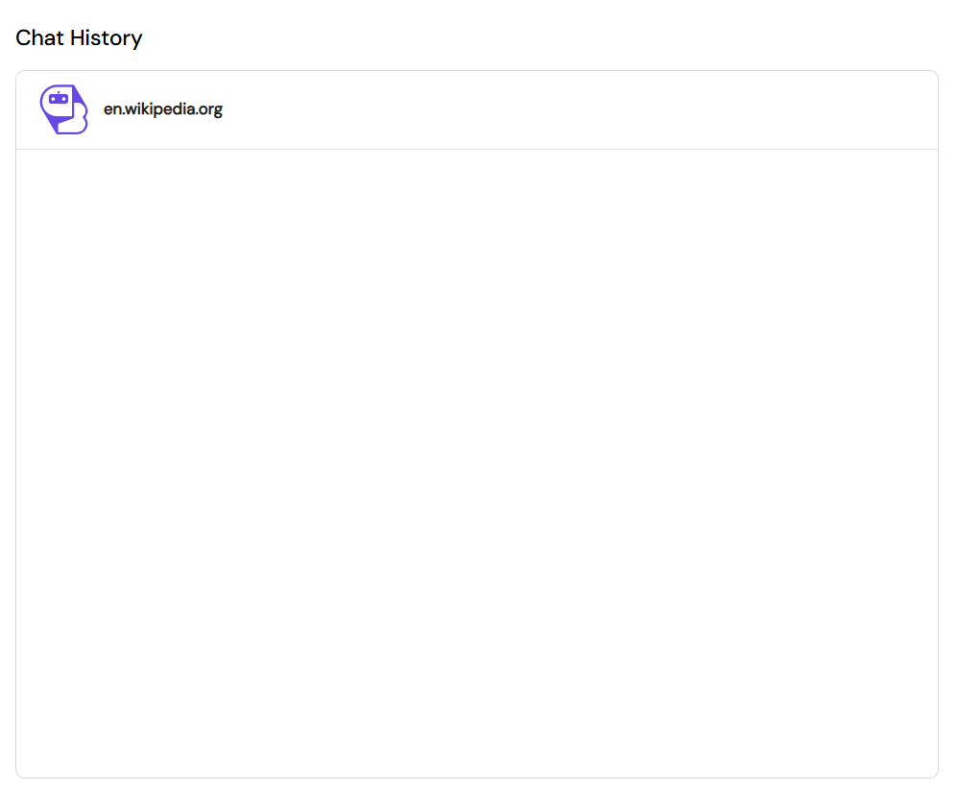

* Chat history section is very unclear and difficult to understand and spot. Also the current selected chat history shall be highlighted so one knows that this chat history is selected:

(UI)

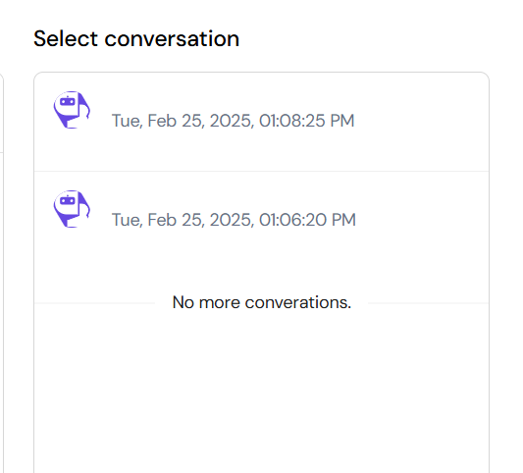

1. Widget Setting

* Cannot update chat icon as chatbot profile picture is being stored in it for some reason? (Functional)
* When saving I am getting this error on console. This is due to when I update chatbot profile picture and chatbot icon. Every other setting is able to change and save but when I update these 2 it doesn’t save and give this error: (Functional)

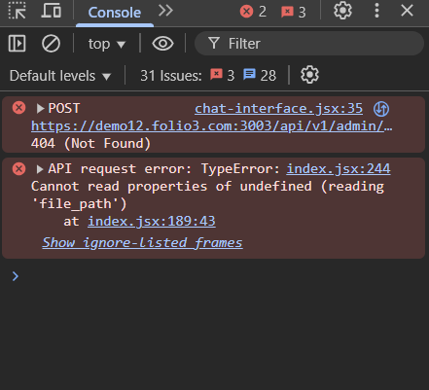

* The close button on the side displayed bot in dark theme stops looking clear: (UI)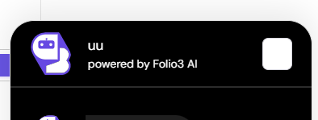

1. I can’t test Access control and Add not to your site as I can’t use it on live websites.
2. Suggestions

* The alignment is off of the chatbots in my chatbot section. (UI)

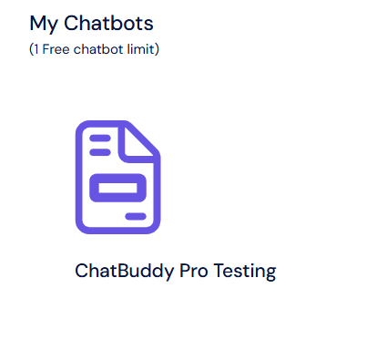

* When we click Logout there isn’t any confirmation box so if user accidently clicks on the logout button he will directly be logged out.